**Home Link**

User can go to home page anytime simply by clicking on the eTaqreeb logo

**FAQ**

The site contains multiple functionalities from which some maybe not very obvious or visible & known to everyone. Therefore the user may require some help A help section for the users is made.

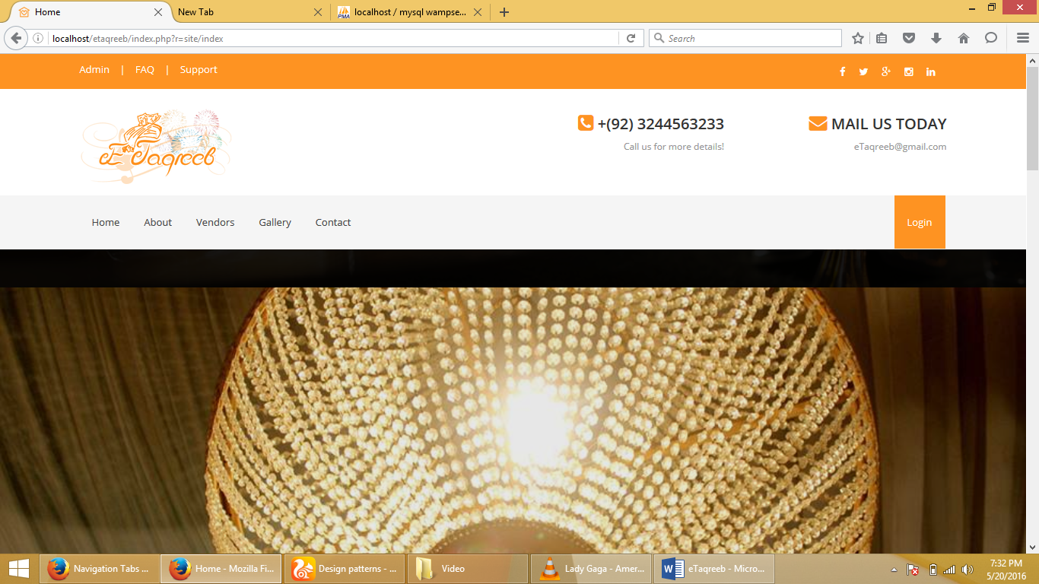

**Navigation Tabs**

There are five pages user can access through navigation tabs

**Model**

Model is used to provide login screen to the users, user can login as a vendor or a customer

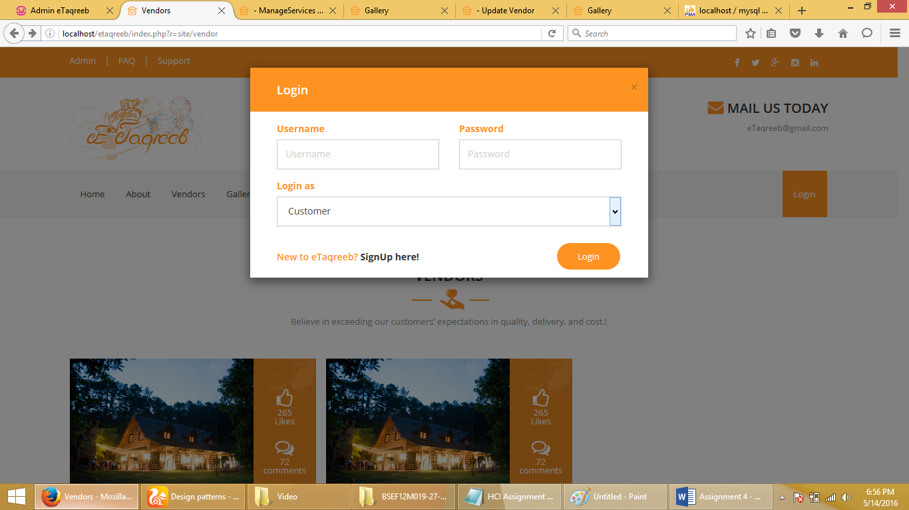

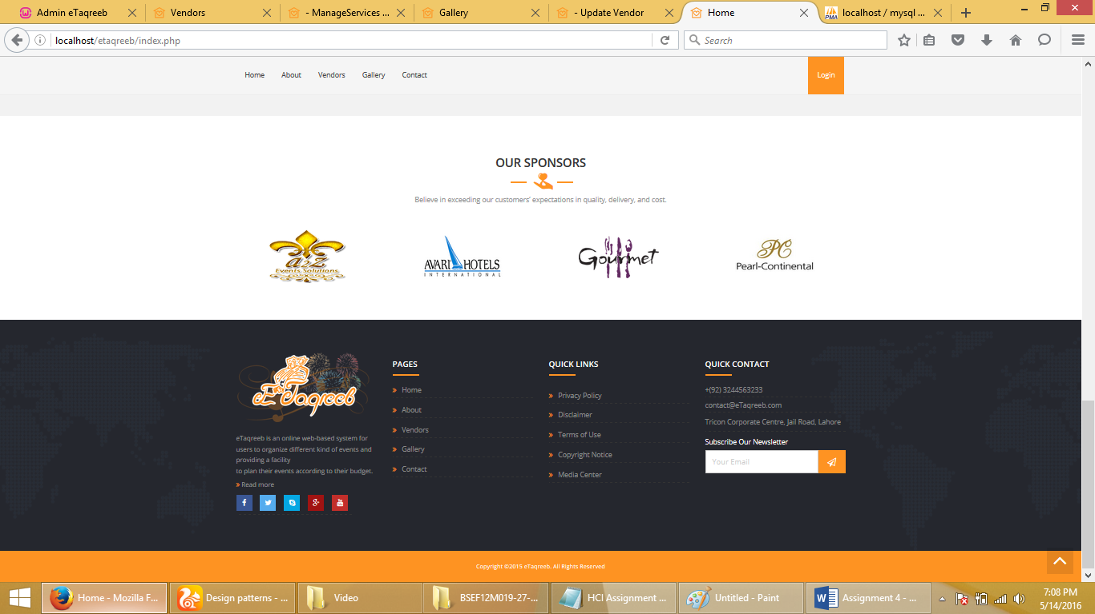

**Fat Footer**

Users need a mechanism that will enable them to quickly access specific sections of a site or application bypassing the navigational structure.

**Slide Show**

A collection of media needs to be displayed in a presentation as a sequence of still images.

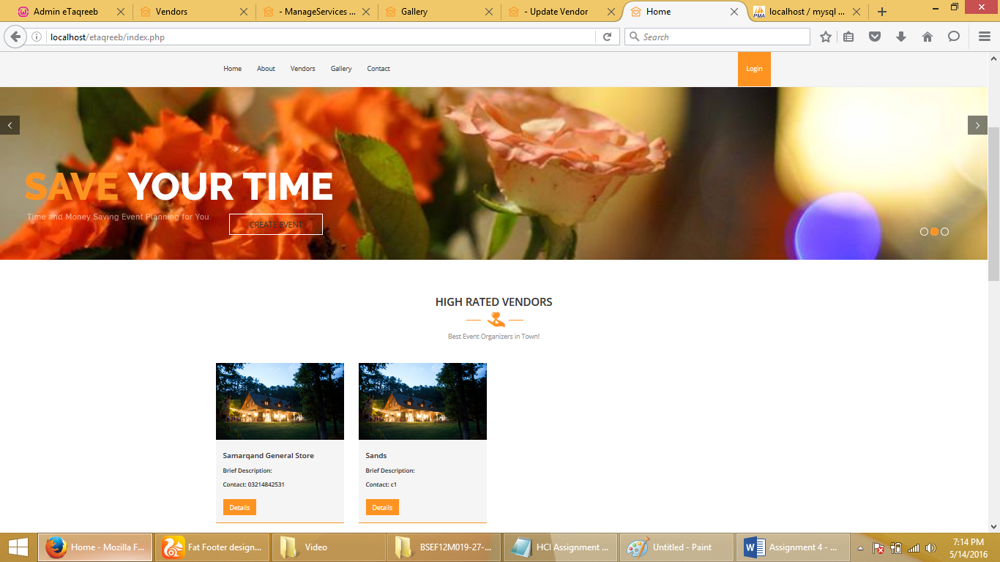

**Vote to Promote**

The user wants to promote a specific piece of content in order to democratically help decide what content is more popular.

**Cards**

The user needs to browse content of varying types and length

**Vertical Dropdown**

User can access all function related to its account in a vertical dropdown

**Gallery**

The user needs to browse a collection of high quality images

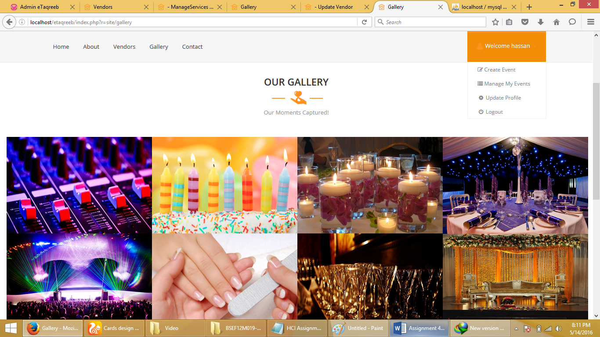

**Carousel**

The user needs to browse through a set of items and possibly select one of them

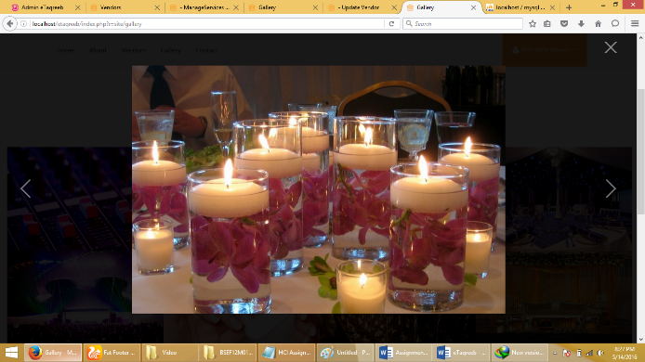

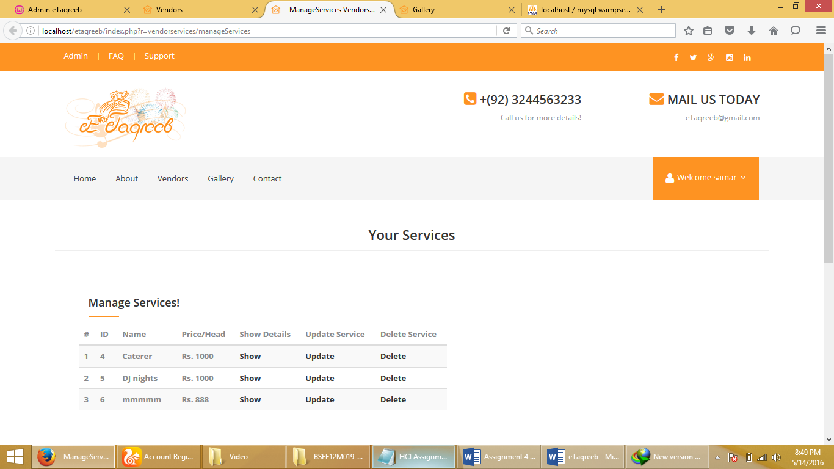

**Alternating Row Colors**

To differentiate table rows from each other, a different shade is used as background color for every second row.

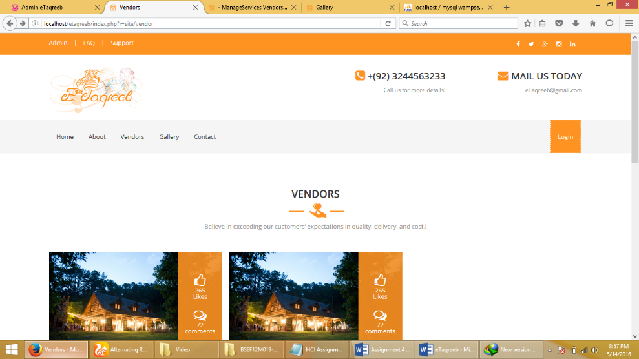

**Rate Content**

Let users rate content in order to democratically help decide what is of higher quality.

**Input Prompts**

When a user fills out a form it is most often with the purpose of filling it out as quickly as possible to get on with the service offered.

**Account Registration**

You wish to know who the active user is in order to provide personalized content or opportunities to conduct a purchase.

